SKILL-16
- To Detect Background Jobs, Launch Non-Blocking Processes, Return Prompt Immediately, Store Job Information, Monitor Execution, Test Background Tasks.
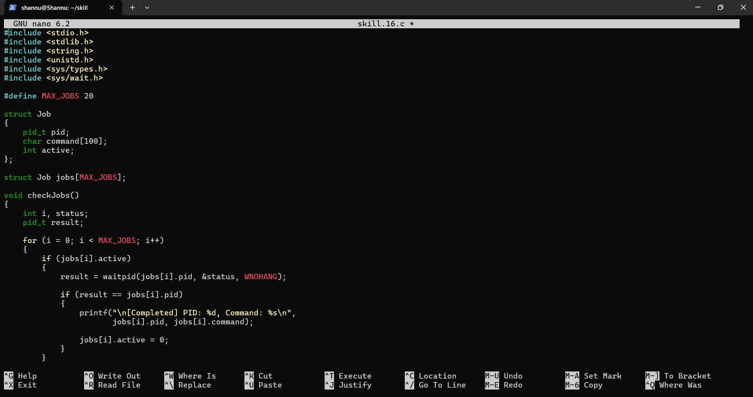
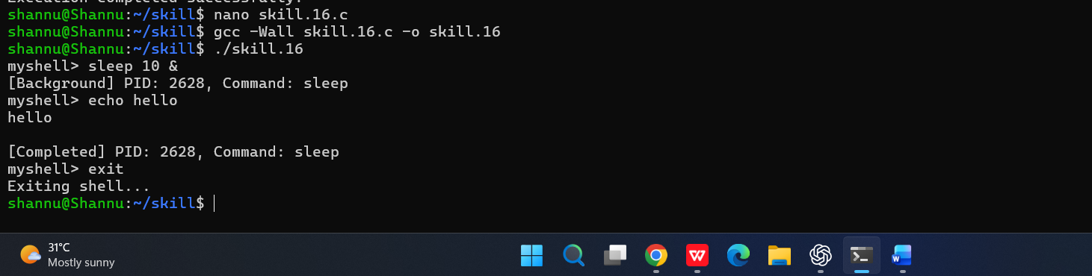

To Create Job Table, Store Process Groups, Track States, Update Status, Remove Completed Jobs, Validate Job Records.
